**MODEL EXAM -2**

**SET -3**

**NO.OF VOWELS AND CONSONANTS**

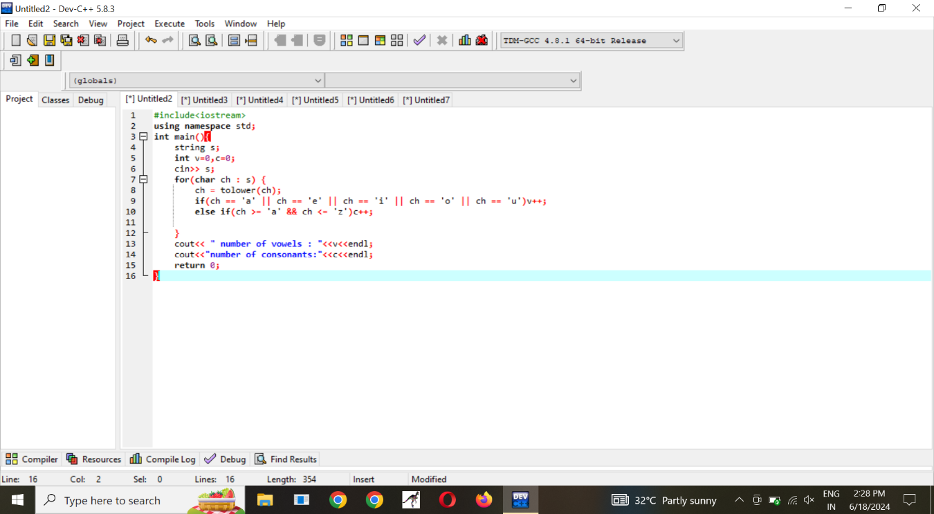

**VOTE ELIGIBILITY**

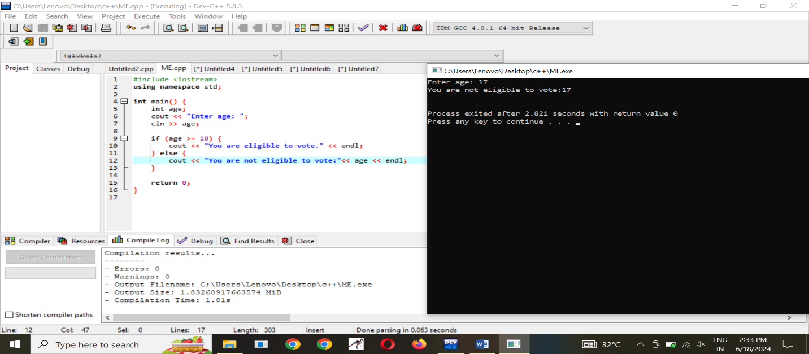

**CLASS BANK BALANCE**

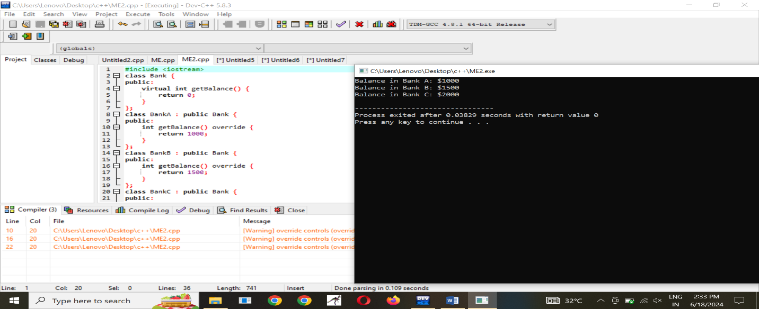

**CELSIUS TO FAHREINHEIT**

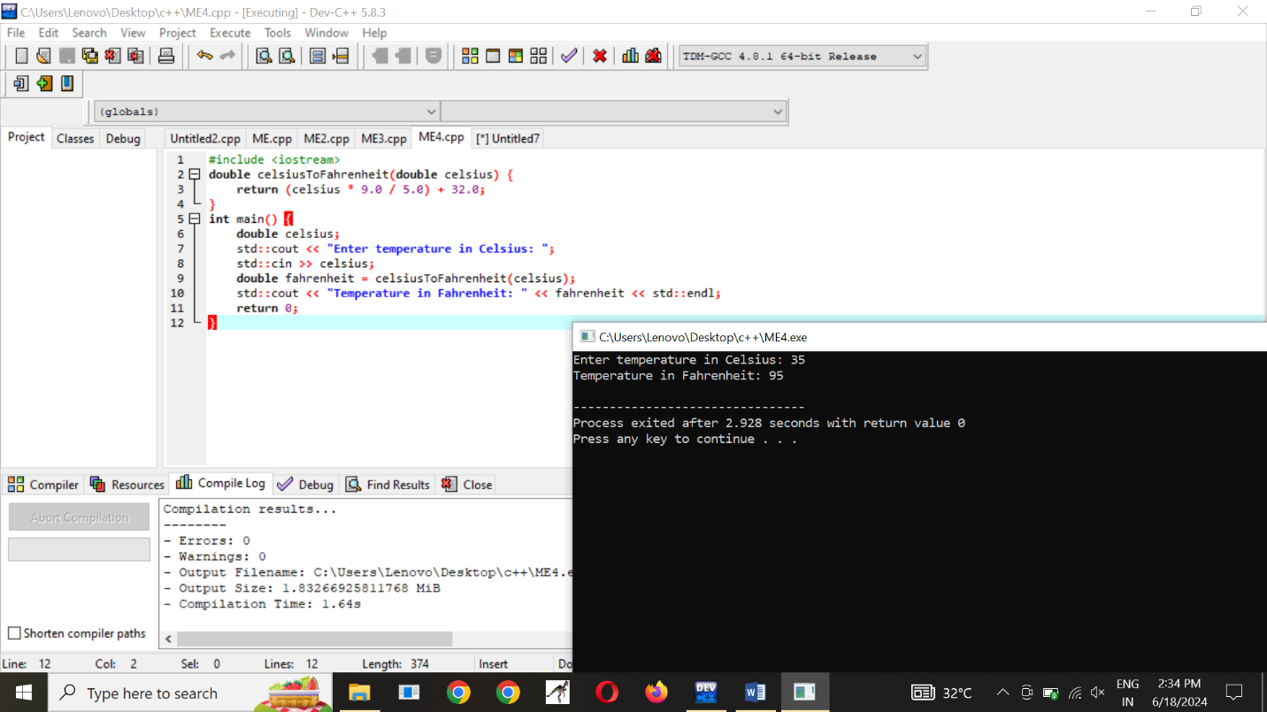

**AREA OF CIRCLE AND SQUARE**

